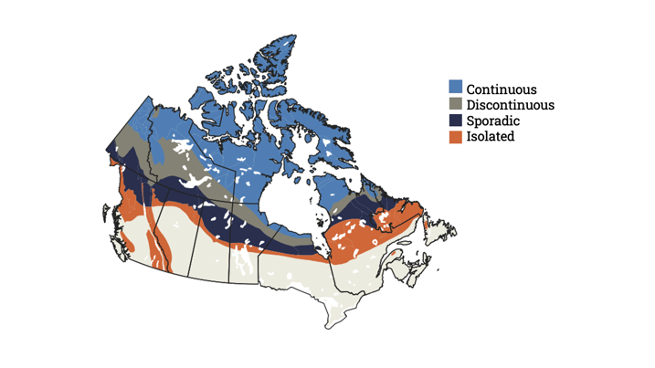
Title (20 words max)
Authors (20 words max). 1st author underlined,
second author and third author.
1. University of … 2. University of …
Study locations: 20 Words
Keywords: 10 max.

This paragraph should focus on the next practices, as an introduction, but may cover key points, take home messages or an overall description of the issue the project is addressing.
Suggested structure:
One or two sentences that explain next practice – what we can now do or understand that we could not before e.g. “This research now enables us to …..”
One or two sentences that explain why that is important e.g. “This is important because ….”
One or two sentences that describe an example of how this research could be used and by whom e.g. “For example, …”
Max. 100 words

Caption that explains the image
IMAGE TO REPLACE THIS TEXT BOX

Figure 1.

Research summary
Suggested structure:
One or two sentences that introduce the basic, general problem.
One or two sentences that explain the specific problem solved.
One sentence explaining what was done here.
One sentence explaining how it was done (methodology).
One to three sentences explaining the results.
One or two sentences putting the results into context (New? Surprising? Incremental or ground-breaking?).
One to three sentences that explain how the next practice described in the first sentence arises from the results.
Max. 150 words.
Caption that explains the image
IMAGE TO REPLACE THIS TEXT BOX

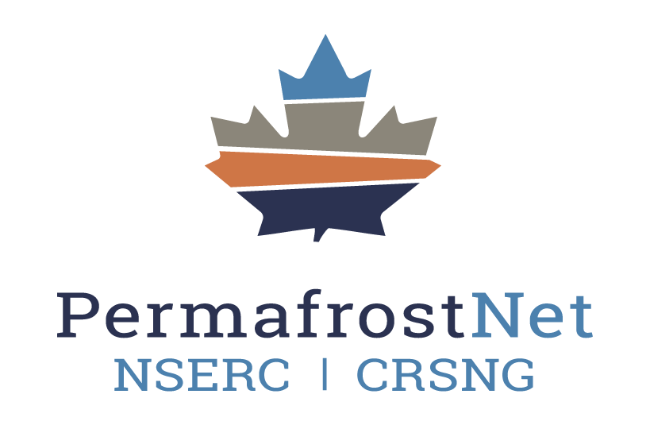
Figure 2.
More figures if useful and feasible on second page.

Taking action
This paragraph provides next steps to address issues caused by thawing permafrost. Provide specific information and actionable steps. Three to four sentences. Max. 150 words

Connections to other projects
This box describes connections to other projects and themes along with colour coded icons to enable quick and easy reference. Max. 50 words
1
2
3
4
5

Partners, team members and support
One to three sentences describing how partners, additional team members such as Northern Research Assistants or technicians, partnership such as shared fieldwork etc. enabled this research. Add a personal touch as appropriate.
Affiliations:
- your university
- NSERC PermafrostNet
- Northern organizations.
Max. 100 words

Acknowledgment, thanks and funding
Include a sentence thanking the community /territory who provided assistance.
Include a sentence acknowledging the land and rights holders where this research was located.
This work was supported by the Natural Sciences and Engineering Research Council of Canada (NSERC), NSERC PermafrostNet and [INCLUDE ADDITIONAL FUNDING HERE].
Max. 100 words

References
Include papers, theses or links to other media and information such as data, code or video files that were published from this project.

